Brevet Major Philip Stafford Gordon Wainman
2nd Worcestershire Regiment (Second Battalion)
Born on September 27th 1879 and Killed in Action September 26th 1915
Buried in Vermelles British Military Cemetery, Loos, France
(See the following related web sites http://www.findagrave.com/cgi-bin/fg.cgi?page=gr&GRid=17157701;
http://www.bloxhamschoolwardead.co.uk/id3.html )

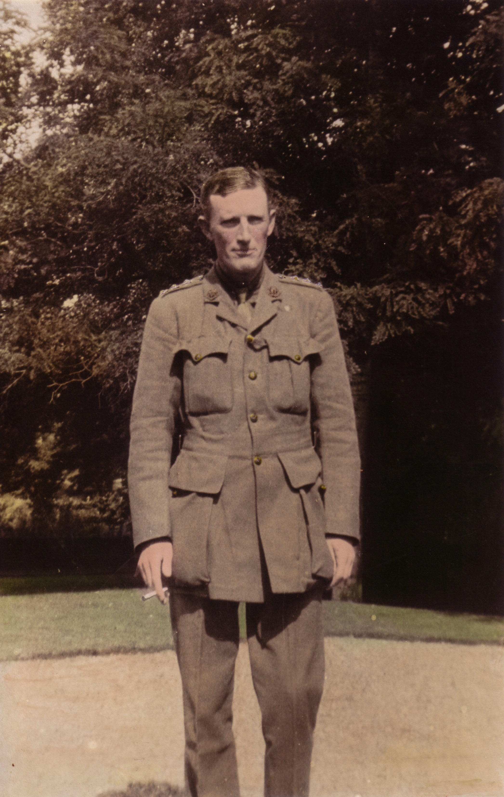
Philip Stafford Gordon Wainman, about 1915, at Otterington Hall

Philip Stafford Gordon Wainman was born on September 27th 1879, the only son of Lt. Gordon Wainman (hailing from an old Yorkshire family) (1850-1845) and Evelyn Charlotte née Harding (1853-1952) of Bideford North Devon. Philip Wainman attended Bloxham school from 1891-1892, followed by Fettes College in Edinburgh and then entered the Royal Military Academy, Sandhurst in 1897. He was known for his excellence in polo, riding and shooting. He obtained his Regiment Commission in 1898 and fought in the Boer War from 1900-1902 and was wounded in action in the Kwa Zulu Natal, receiving the Queen’s and King’s Medals with 2 clasps, being promoted to Captain in 1902.

Philip Wainman immediately rejoined his original Regiment on the outbreak of World War 1, and went to France on October 1st 1914. Despatches from Field Marshal Sir John French in 1915 cited “gallant and distinguished services in the Field”. He led his men into action at the Battle of Loos. His epitaph cites "Killed in action whilst leading his men into battle on the eve of his 36th birthday." He was appointed Brevet Major on the day he was killed. He is also remembered on the War Memorial outside Worcester Cathedral.

Philip Wainman was married on January 14th 1904 in Philadelphia to Miss Christine Ledlie Wheeler of Bryn Mawr, Pennsylvania. They resided in Otterington Hall from 1909 after Philip’s postings in Jamaica and Devon. They had four sons, Philip, Charles, William and Alexander. All four had military careers with distinction. Philip Wainman’s grandchildren and descendants have set root in England, Scotland, France, and Greece.

John Alexander Wainman (grandson),
Paris, France
September 13th 2009

Email : jw@wainmanagement.com

